Nama : Servasius Khristna Budi Kurniawan

Nim : A11.2019.11674

Data Training

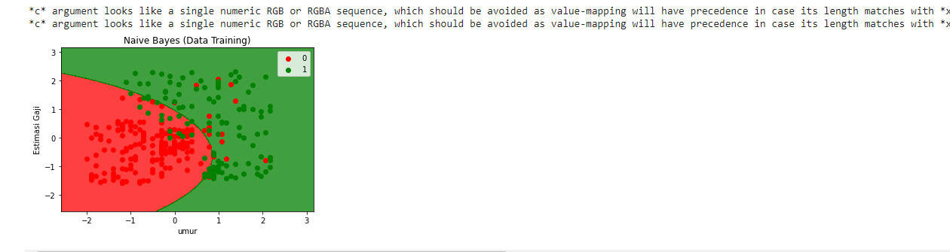

Data Test

